DAS

Data Acquisition System (DAS) consists of a set of computers and electronics controlling the acquisition and storage of data collected at each instrument at SNS. The das-opi computer is the main computer and most of the work for setting up runs occurs on this computer. There are three monitors for the das-opi computer towards the left side of the hutch (Figure 1). On the right side of the hutch are computers for data reduction, visualization and analysis.

Figure 1. NOMAD hutch, showing the analysis and control computers.

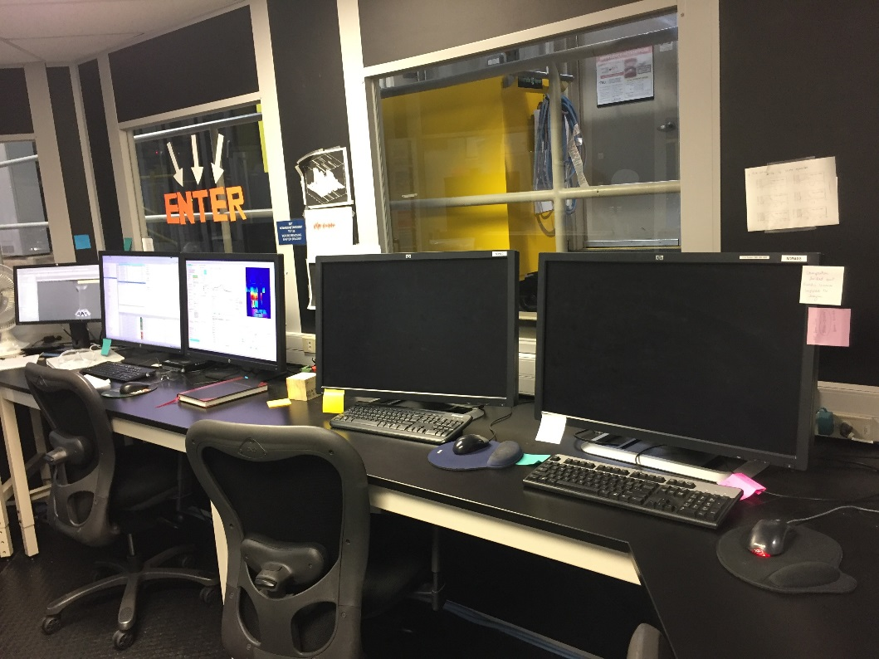

NOMAD3: analysis

NOMAD: analysis

Das-opi: control

Das-opi: control

Das-opi: control

Dashboard

The right monitor of the das-opi control computer displays the instrument dashboard (Figure 2). The dashboard contains all the information and controls a user will need for a typical experiment.

Figure 2. Dashboard general layout.

Instrument Status Display The left column (Figure 3) of the dashboard displays instrument status, including the beam power and shutter status indicators at the top. During data collection, typically, all indicators should be green. Scan status and run information are shown in the Run Information box, where a scan is a collection of runs. If data collection is not controlled by a table scan script (see below), the scan status can be yellow. The total time and collected beam proton charge of the current run are indicated here. The Count Rate also deserves one’s attention as it is often indicative of how well a sample is aligned in the beam, and/or how strongly a sample scatters; thus, it is a good practice to write down this number when running the empty instrument, sample containers and samples, respectively. The sample name, composition and other details are shown in the Sample Information box. The Proposal Information box indicates the currently selected proposal. In the Beam Information box is the status of the bandwidth choppers, including the center wavelength and frequency. These very rarely change. The Message Board box can be used by facility staff logged in and controlling parameters from the outside.

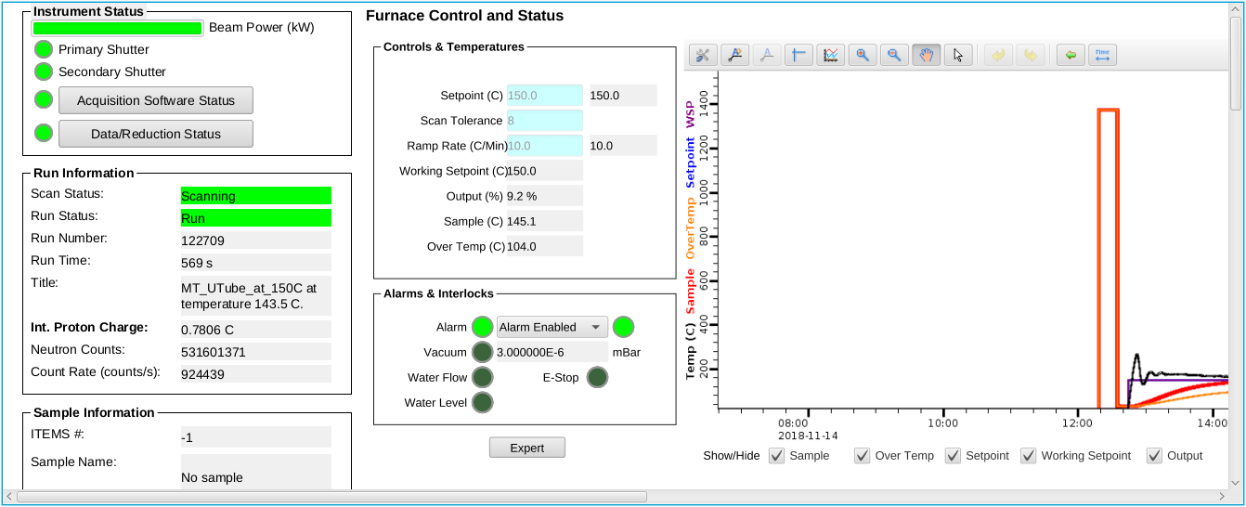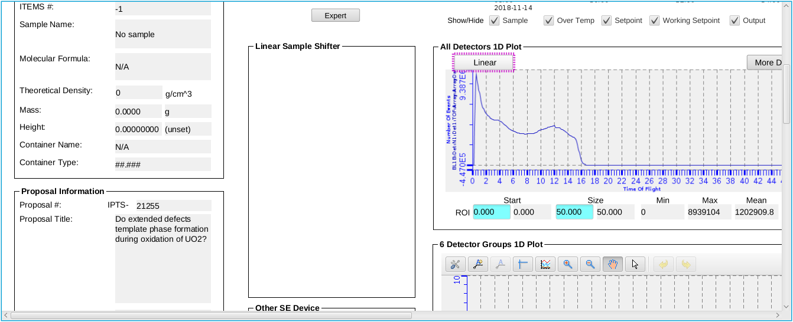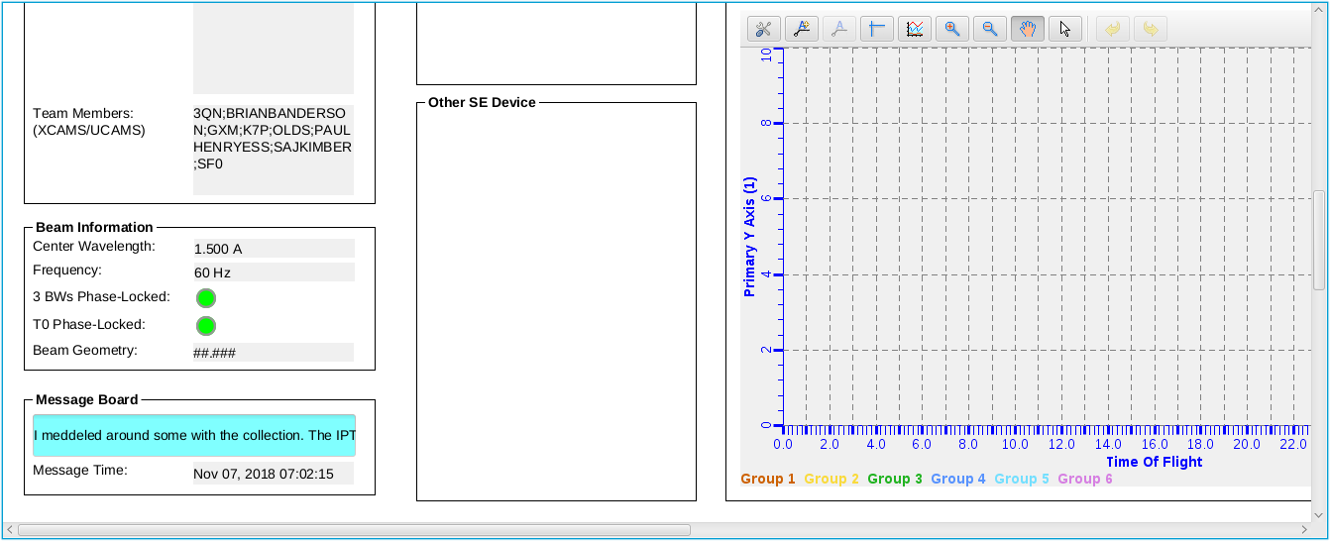

Figure 3. Instrument Status Display

Sample Environment Controls The upper center section (Figure 4) of the dashboard displays a plot of the sample temperature and sample environment controls, including the setpoint, ramp rate and tolerance. These parameters can only be changed when not running a script. The left side of the lower center section (Figure 5) displays a couple of other sample environment controls, such as the Linear Sample Shifter.

Data Plots The right side of the lower center section (underneath the temperature plot) displays the 1D plot for all the detectors (Figure 5), showing the diffraction data, summed across all detectors, as a function of d-spacing, Q or time-of-flight (tof). This is followed by the 1D plot for each of the six detector groups (Figure 5). While these plots are mostly useless, they can give a rough idea if a sample in the beam is amorphous or crystalline.

The right section (Figure 6) of the dashboard displays the 2D plot of all the detectors at the top, which shows the total counts across each detector face; although also mostly useless, it is indicative of the detectors’ operating status. Thus, if a group of detectors stops reporting, beamline personnel or the instrument hall coordinator will be notified. The bottom plot of the right section (Figure 6) shows the beam monitor spectrum.

A screenshot of a cell phone

Description generated with very high confidenceFigure 4. Center area of the dashboard, showing temperature controls at the top.

Figure 5. Center area of the dashboard, showing detectors 1D plots at the bottom.

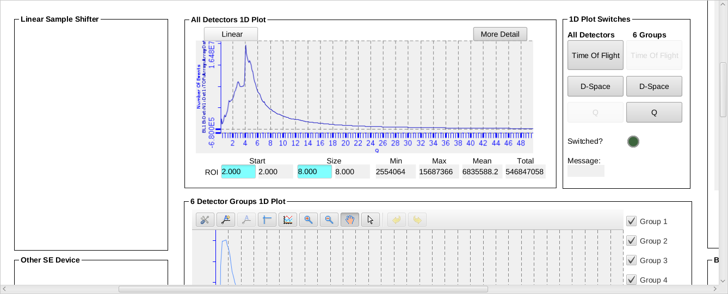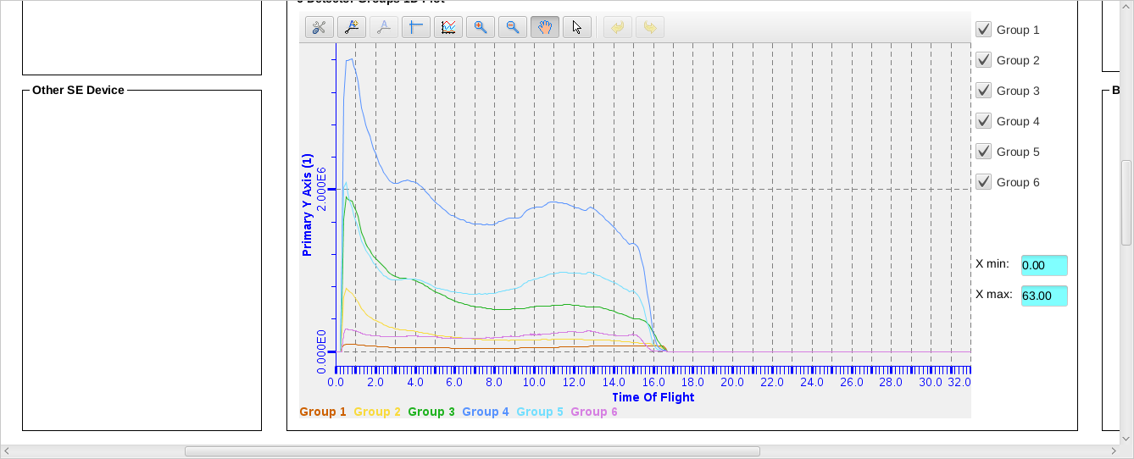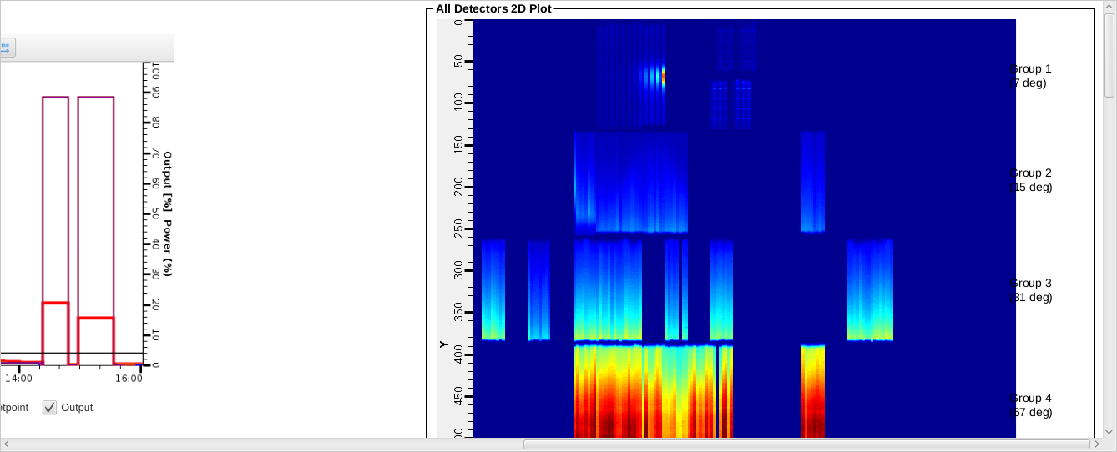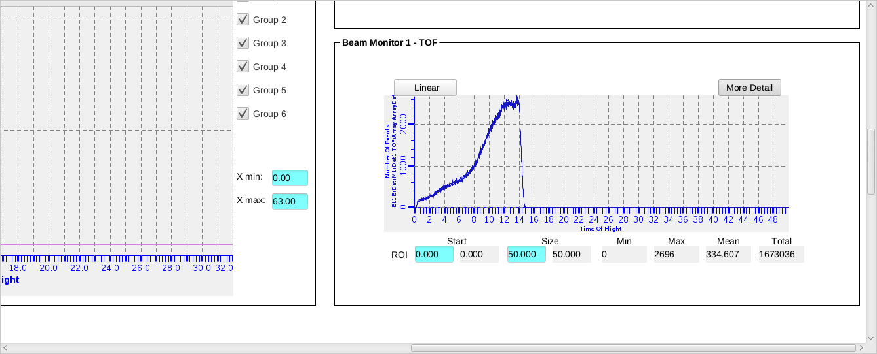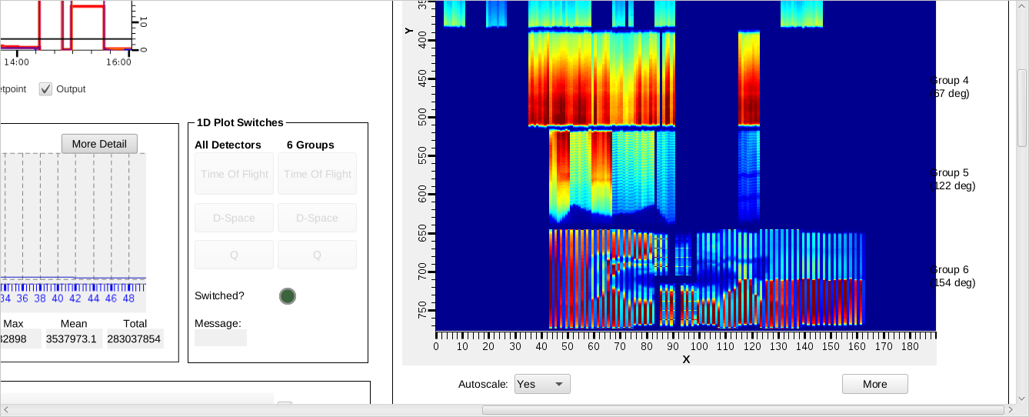

Figure 6. Right column of the dashboard, showing 2D plots of detectors and beam monitor data.



Figure 7. Graph Toolbar, with the Configure Settings, Perform Autoscale and Rubberband Zoom buttons highlighted (left to right).

Plot options are available by right-clicking in the plot area and selecting Show/Hide Graph Toolbar (Figure 7). By default, the plot will autoscale in both the x- and y-axes. In order to zoom in, you must disable autoscale by clicking the Configure Settings button on the left end of the graph toolbar, going to the Axes tab, selecting the desired axis from the dropdown menu and then unchecking the Auto Scale Enabled option. Once autoscale is disabled, you may click the Rubberband Zoom button in the graph toolbar and then click and drag on the plot to zoom in. Clicking the Perform Autoscale button in the graph toolbar will zoom the plot back full.

Additional Screens

Additional screens (Figure 8) are available on the middle monitor of the das-opi control computer with more instrument controls information. Typically, a user will only navigate to the table scan tab for managing scan scripts (see below) or the user start page for manual run control. Sample alignment in the Shifter sample environment is described separately. The Navigator pane on the extreme left displays the file structure. Files may be opened from the Navigator pane by double-clicking. To the right of the Navigator pane is the section containing several tabs with more information about the beamline equipment, along with the Scan Monitor pane at the bottom. The NOMAD tab has indicator lights for the status of each piece of beamline equipment. All status lights should be green when functioning properly. The Table Scan tab contains table scan controls as will be described in detail below (Figure 9). The User_Start_Page tab allows users to start and stop data acquisition manually. The Cryostream tab shows the status of the sample changer (Shifter). The Furnace tab shows the temperature controls and plots, as in the Dashboard (Figure 4). Other tabs may be present depending on the sample environment equipment installed at the beamline, such as Cryostat.

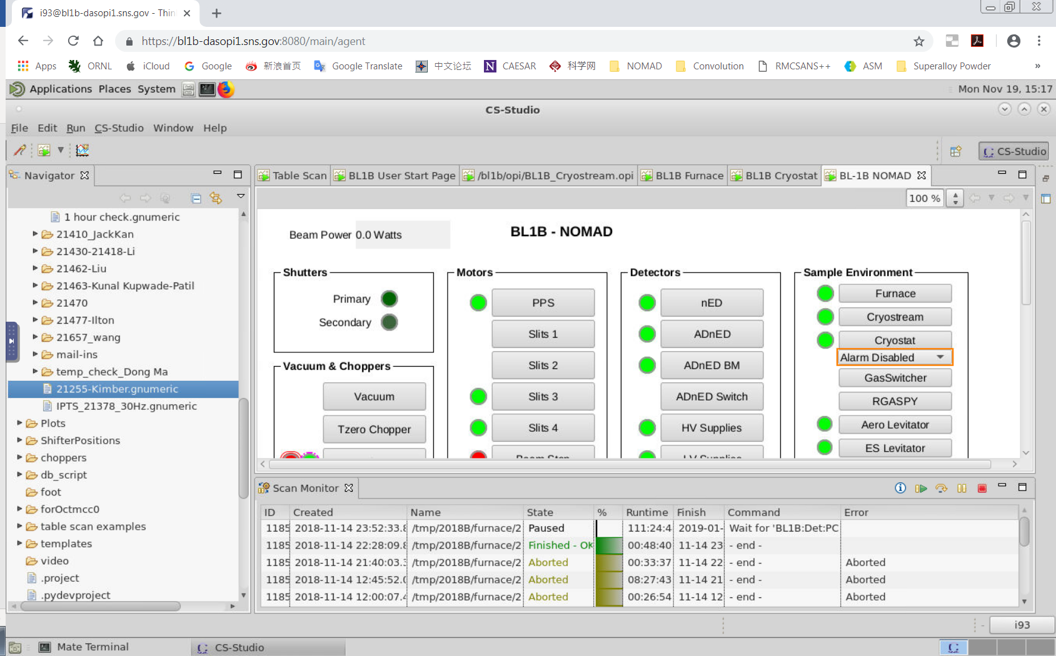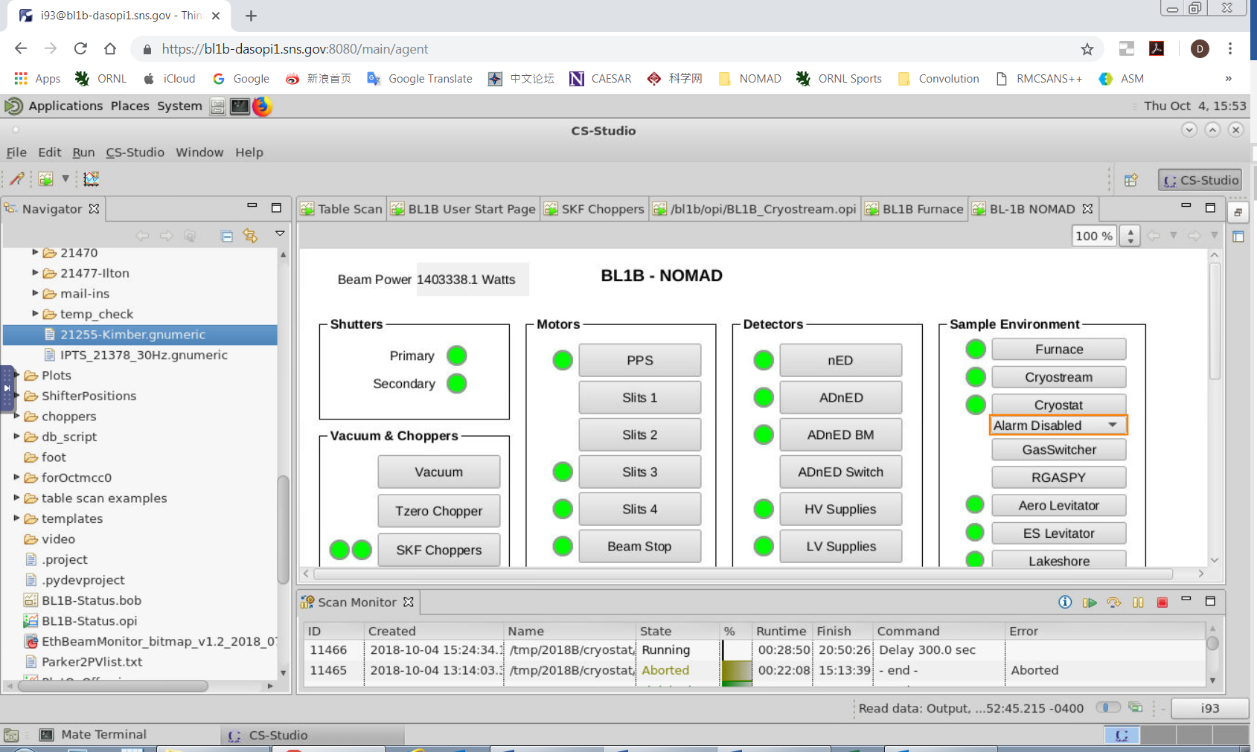

Figure 8. Additional screens shown on the middle monitor of the control computer, showing controls of beamline equipment.

Table Scan Scripts

The preferred mode of data collection is using table scans (Figure 9), which are spreadsheet files that lay out the desired data collection and instrument steps, e.g. count time, sample temperature and sample changer position. User table scans are saved in the folder temp/cycle/SE/IPTS-XXXXX, where cycle is the run cycle (e.g. 2018B), SE is the sample environment (e.g. shifter) and XXXXX is the proposal number. Example scripts for each instrument setup are in the temp/table_scan_examples folder. They may be opened and changed with the Gnumeric program.

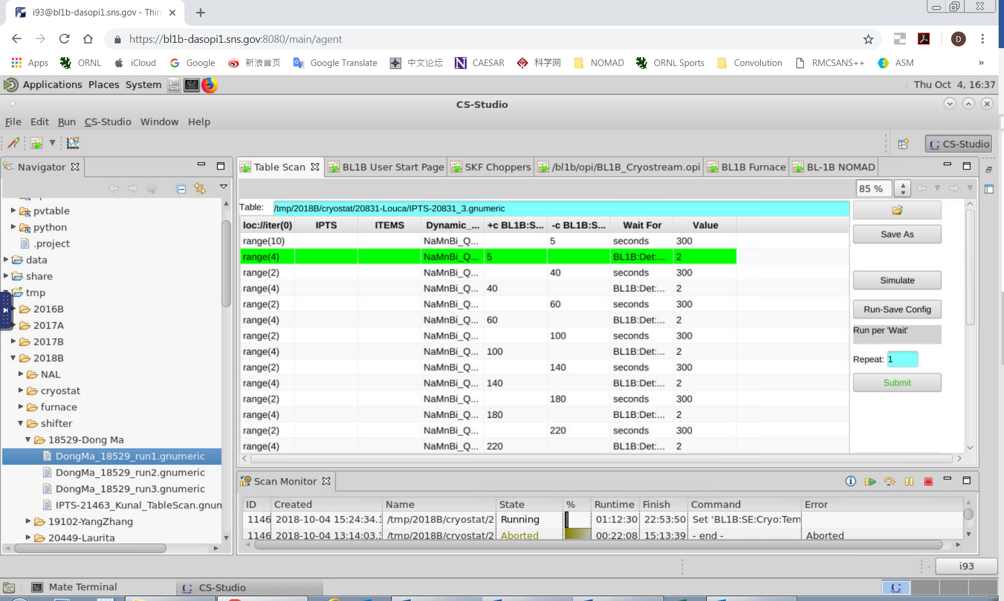

Figure 9. Additional screens shown on the left monitor of the control computer, showing table scan controls.

*Preparing a Script* To prepare a table scan, copy the appropriate example script into your proposal folder and rename it appropriately. Open the script in Gnumeric and replace the example values with your desired values. Each line contains the instrument and data collection parameters for one scan (or one set of similar scans). Table 1 describes the meaning of each column heading. Each line of the table will be executed successively. For extra commands, checkout the help button on the table scan page.

**Table 1. Table scan script column headings.**

|  |  |
| --- | --- |
| Column Heading | Description |
| General Settings | |
| Dynamic_name | title for the run, appends temperature at run start to the run title |
| ITEMS | Sample ID (can be found under the barcode on the label) |
| IPTS | your proposal number |
| range(x) | repeat this line for x times |
| Loc://counter(0) | counter |
| Wait For | criteria to use to signal the end of the run, typically BL1B:Det:PCharge:C, or seconds |
| Value | value of criteria to signal the end of the run |
| Shifter Sample Changer Settings | |
| sample | sample position (1-10) for run |
| BL1B:SE:Cryostream:RRATE | ramp rate in K/hour |
| +c temp_SHIFT | sample temperature in K, waits for completion of temp change to start collecting data (collect while at temp) |
| -c temp_SHIFT | sample temperature in K, does not wait for completion to collect data (collect during ramping) |
| Orange Cryostat Settings | |
| +c BL1B:SE:Cryo:TempsetpointSet | sample temperature in K, collect while at temp |
| -c BL1B:SE:Cryo:TempsetpointSet | sample temperature in K, collect during ramping |
| BL1B:SE:Cryo:RampRateSet | ramp rate in K/min |
| Furnace Settings | |
| +c BL1B:SE:ND1:Loop1:SP:SPSet | sample temperature in °C, collect while at temp |
| -c BL1B:SE:ND1:Loop1:SP:SPSet | sample temperature in °C, collect during ramping |
| BL1B:SE:ND1:Loop1:SP:RateSet | ramp rate in °C /min |

Most data acquisition process variables can be utilized in the table scan format. Names of process variables can be copied by right clicking on a controls field and selecting “Copy PV name to clip-board”. The variable can be pasted as a column heading in the scan table. Work with the beamline team to create custom scripts. Data is typically collected either for a specified time (for example, during a time-sensitive material process) or a specified cumulative beam power (known as pCharge). At NOMAD, we most often collect on pCharge. When collecting on pCharge, data collection time will be extended if the neutron beam goes down during a run, in order to reach the same beam exposure run to run. The expected amount of pCharge collected in one hour depends on the beam power, as listed in Table 2.

**Table 2. Accumulated beam per hour, as a function of beam power.**

|  |  |
| --- | --- |
| **Beam Power (MW)** | **pCharge per hour (coulomb/hr)** |
| 0.850 | 3.3 |
| 1.0 | 3.7 |
| 1.1 | 4.3 |
| 1.2 | 4.5 |
| 1.3 | 4.7 |
| 1.4 | 5.4 |

*Simulation* Once your table scan file is prepared, you may simulate it. The program will run through the script, line-by-line, without actually issuing any control parameters, and it gives a very rough estimate of the total time. To simulate a script, it must first be loaded into the EPICS software. On the Table Scan pane (Figure 9), click on the folder icon. Browse to select your file. Once the correct path and filename are displayed to the left of the folder button, the script will be automatically loaded. The table below should be filled with the entries from your script. Finally, press the Simulate button. A new window will pop up and the simulation output will be displayed. Each change of an instrument setting will be outlined, along with the estimated time to execute each line of the script, and at the bottom, the total estimated time to execute the entire script. Check the simulation output carefully to ensure that everything is as expected.

*Submitting a Script* Once your script is ready and the simulation output has been verified, you may run your script by pressing the Submit button (Figure 9). It is often advisable to set a repeat value. Note that a script can always be stopped by pressing the Abort button on the Scan Monitor Pane (Figures 8 and 9), which looks like a red square in the right lower corner. If you are not sure that you will be at the beamline for the exact conclusion of data acquisition, repeat the scan sequence until you arrive with ensure that useful data is collected.

Once your script is submitted, a line will be added to the top of the Scan Monitor pane (Figures 8 and 9), representing that script. The Scan Monitor shows the filename, status (Aborted, Failed, Finished or Running), runtime, estimated finish time and which command is currently executing. Double clicking a script in the Scan Monitor pane displays the Scan Editor, which shows the list of commands to be executed, with the current command highlighted in green text. Be very cautious when doing this. Opening a scan this way allows the user to move forward in the scan and may skip steps you didn’t mean to skip.

Separate table scan scripts may be queued. While the first script is running, load and submit the second script. It will be added to the top of the Scan Monitor pane and will automatically be executed once the first script finishes.

To abort a currently running script, you may press the Abort button on the Scan Monitor Pane (Figure 8), which looks like a red square. You may also pause and resume a currently running script by pressing the appropriate buttons on the Scan Monitor Pane.